# Worksheet 12

1. Load the image and geometry libraries.
2. Load lines.jpg in image matrix: IMG

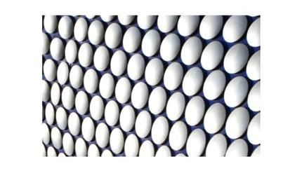

1. Convert the image to grayscale
2. Experiment with manual and adaptive thresholding to convert the image to binary using the computed threshold.
3. Complement the image using threshold mode cv2.THRESH_BINARY_INV or an invert function following a normal threshold

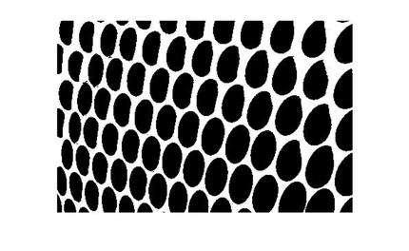

1. Research and use cv2.findContours() to read and store the boundaries found in the image.
2. Use the cv2.drawContours() function to display the contours and display text of the number of boundaries found.

# Sample Output:

